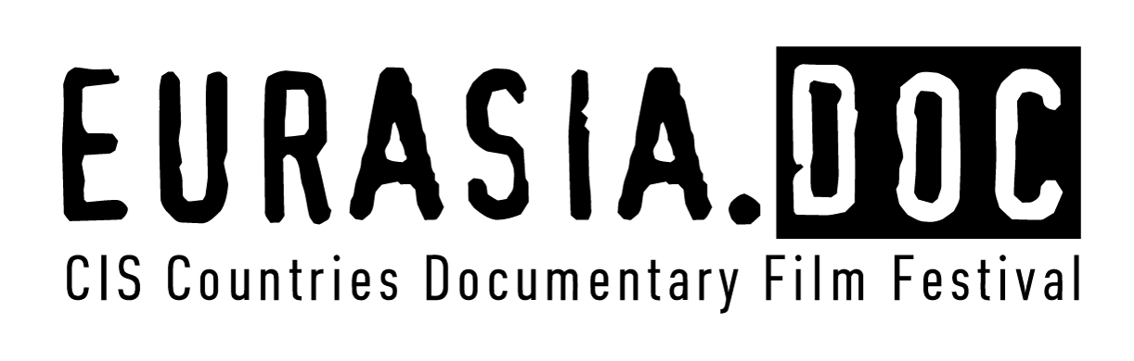

Application Form

Participation in the Eurasia.DOC CIS Countries Documentary Film Festival

1. Film title______________________________________________
_____________________________________________

2. Name of the studio (organization) presenting the film or name of the copyright owner_____________________________________
_________________________________________________________
_________________________________________________________
3. Filmmakers:

Scriptwriter_________________________________________________
Film director__________________________________________________
Cameraman__________________________________________________
Sound operator_____________________________________________
Music by________________________________________________
Producer_________________________________________________

4. Film brief synopsis ________________________________________________
______________________________________________________________________________________________________________________________________________________________________________________________________________________________________________________________________________________________________________________________________________________________________________________________________________________
5. Brief biography of the film director ______________________________
__________________________________________________________
__________________________________________________________
__________________________________________________________
6. Filmography of the film director (selection) __________
__________________________________________________________
__________________________________________________________
__________________________________________________________
__________________________________________________________
7. Film duration_______________________________

8. End date of film production____________________________

9. Festivals and film demonstrations, where the film was presented, and awards received in these events
__________________________________________________________
__________________________________________________________
__________________________________________________________

10. Address of the organization presenting the film or the copyright owner ____________________________________________
____________________________________________________________________________________________________________________
Telephone/Fax______________________________________________
Email_________________________________________

11. Contact person (name, position, contact telephone number) ____________________________________________________________________________________________________________________

12. Attachment: in jpg or tiff format, 300 dpi, at least 500 Kb (photo of the film director and film frames in electronic form in the JPEG format).

Information on the film shall not be included in the festival catalog, if the following materials are not provided.

The following shall be attached to the application:
1) copy of the film in the DVD format;
2) photo of the film director and film frames in electronic form in the JPEG format;
3) electronic application in the Word format shall be sent to festival email address: info@eurasia.film;

By signing this application I confirm:
–authenticity of the above information;

– acceptance of all the terms and conditions of the Eurasia.DOC CIS Countries Documentary Film Festival Regulations.

Signature of the manager / the copyright owner company

Printed name

